DSA (DATA STRUCTURE + ALGORITHM)
WHAT IS DATA STRUCTURE?
- In Python, a data structure is a specialized format for organizing, processing, retrieving, and storing data. Data Structures are a way of organizing data so that it can be accessed more efficiently depending upon the situation.
- Understanding data structures is crucial for writing efficient and scalable Python code, as the choice of data structure can significantly impact performance for various operations like searching, sorting, insertion, and deletion.
Images:-

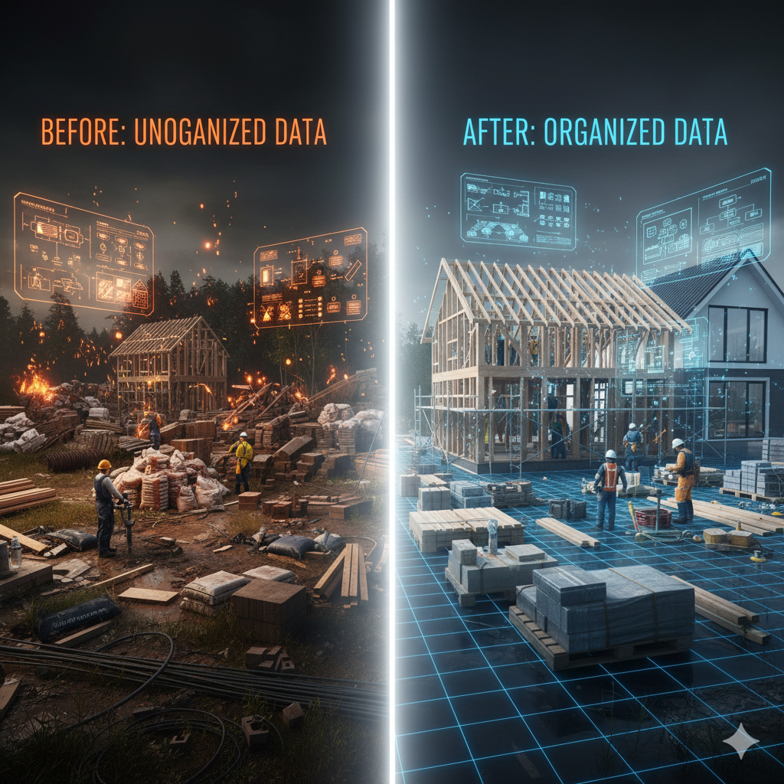


Data structures are dividing into 2 parts
- Primitive data type allows you to store only single data types values such as integers, float, string, and Boolean.
- Non primitive data type allows you to store multiple data type values such as lists, sets, stacks, etc.
  - Non primitive data types divide into 2 types
    - Build-in / In-build (Linear)
    - User define ( Non Linear)
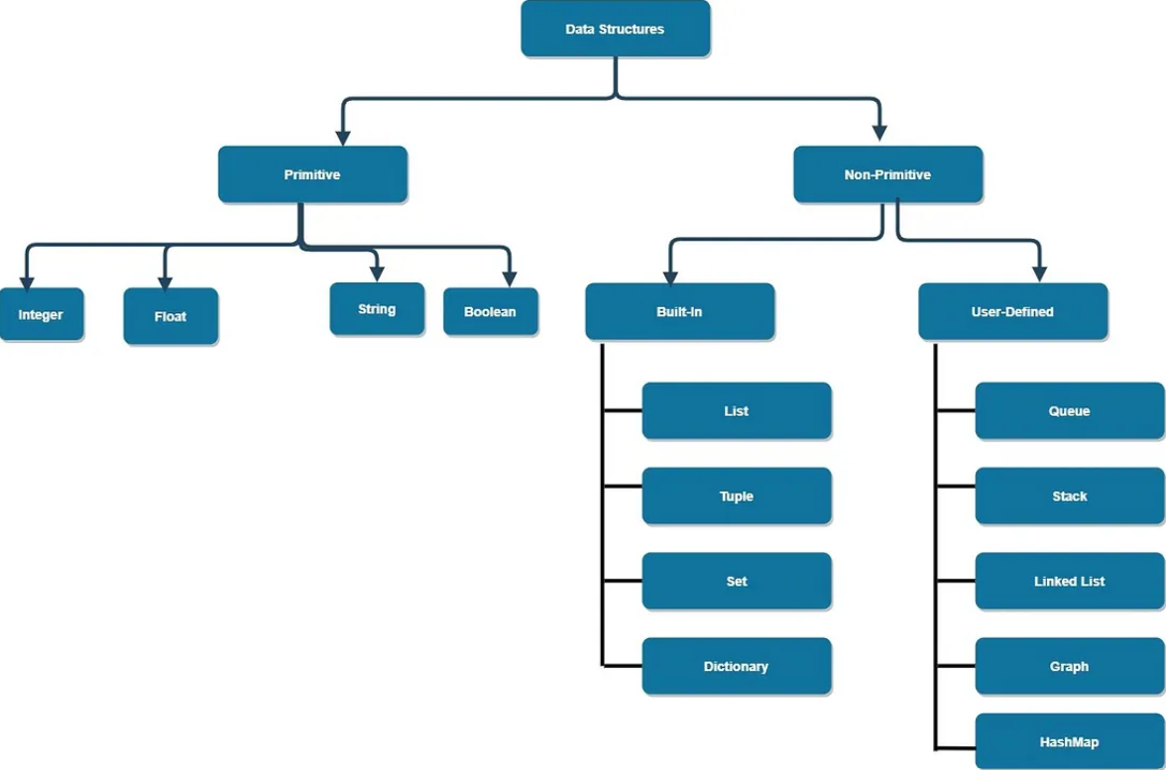

- Data Structures and Algorithms (DSA) are indeed fundamental for cracking interviews at top tech companies like those in MAANG, NVIDIA, and Tesla. They form the backbone of efficient problem-solving and are a core part of technical assessments.


